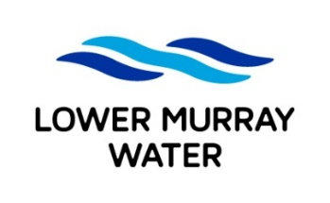

**Job Application Form**

To apply for an LMW position, complete the following fields, attach your **current** resume and email to [recruitment@lmw.vic.gov.au](mailto:recruitment@lmw.vic.gov.au) before the specified closing date/time

|  |  |  |
| --- | --- | --- |
| **POSITION DETAILS** | | |
| **Please indicate the role you wish to apply for:** | **□ Civil & Maintenance Operator – Full-Time Ongoing**  **□ Civil & Maintenance Operator – Full-Time Limited Tenure** | |
|  | |  |
| **YOUR DETAILS** | | |
| **Full name:** |  | |
| **Email:** |  | |
| **Mobile:** |  | |

 LMW is a future-focused organisation which embraces the use of technology such as generative AI (Artificial Intelligence) in supporting and enhancing the work we do.

*To ensure the integrity of our recruitment process and an accurate assessment of your application, we encourage you to submit the form in your own words to reflect your lived experience and values.*

|  |
| --- |
| **APPLICATION QUESTIONS** |

|  |
| --- |
| In addressing the application questions below please include details on your relevant:   * skills/knowledge * qualifications/licences/certificates * examples of experience |
| 1. **Which of the following statements best describes your right to work in Australia?** |
| **I have permanent work rights with no restrictions.**  **I have temporary work rights with no restrictions.**  **I have temporary work rights with restrictions.**  **I require sponsorship to work for a new employer.** |
| 1. **Tell us about a high-risk work-related task you have been involved in? How did you reduce the risk to ensure the task was carried out safely?** – 500 words max. |
|  |
| 1. **Our work can involve working with sewer, working over water, working at heights, how do you feel about performing this work?** – 500 words max. |
|  |
| 1. **Describe a difficult situation you’ve had involving conflict with another person (Customer or Co-worker). How did you handle it? What tactics did you use?** – 500 words max |
|  |